RESOLUTION NO.__________

RE: CERTIFICATE OF APPROPRIATENESS UNDER THE
PROVISIONS OF THE ACT OF THE PENNSYLVANIA
LEGISLATURE 1961, JUNE 13, P.L. 282 (53
SECTION 8004) AND BETHLEHEM ORDINANCE NO.
3952 AS AMENDED.

WHEREAS, it is proposed to secure a COA for renovations to the front façade of the building at 715 – 721 East Fourth Street.

NOW, THEREFORE, BE IT RESOLVED by the Council of the City of Bethlehem that a Certificate of Appropriateness is hereby granted for the proposal.

Sponsored by: (s)

(s)

ADOPTED BY COUNCIL THIS DAY OF

(s)
President of Council

ATTEST:

(s)
City Clerk

HISTORIC CONSERVATION COMMISSION

CASE #656 -- It is proposed to remove the existing aluminum siding at the front façade (only), repair and paint the existing wood siding underneath at 715 – 721 East Fourth Street. It is also proposed is to remove the existing chain link fence and replace with a painted wood picket fence at the same property.

OWNER/APPLICANT: Lenore Hughes (715 – 721 East Fourth Street)/Lynne Holden, Façade Coordinator, Community Action Development Corporation of Bethlehem

The Commission upon motion by Mr. Roeder and seconded by Mr. Evans adopted the proposal that City Council issue a Certificate of Appropriateness for the proposed work as presented and described herein:

- The proposal to renovate the front façade of the building was presented by Lynne Holden.
- Approved exterior renovations include:
  - remove existing aluminum siding at front façade only
  - pressure wash existing wood siding at front façade; repair wood siding as needed and replace damaged/missing boards in-kind, as required; install wood corner detail to transition from wood siding to aluminum siding; paint resulting façade
  - remove aluminum cladding at existing window sills along front façade; repair wood sills as needed and paint
  - covered stoop over entrance door to have hip roof, rather than shed roof as originally approved
- Remove existing chain link fence and replace with painted wood picket fence.
- The motion for the proposed work was unanimously approved.

JBL: jbl
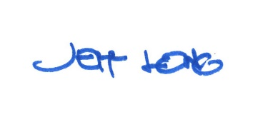

By:

Date of Meeting: July 16, 2018 Title: Historic Officer

